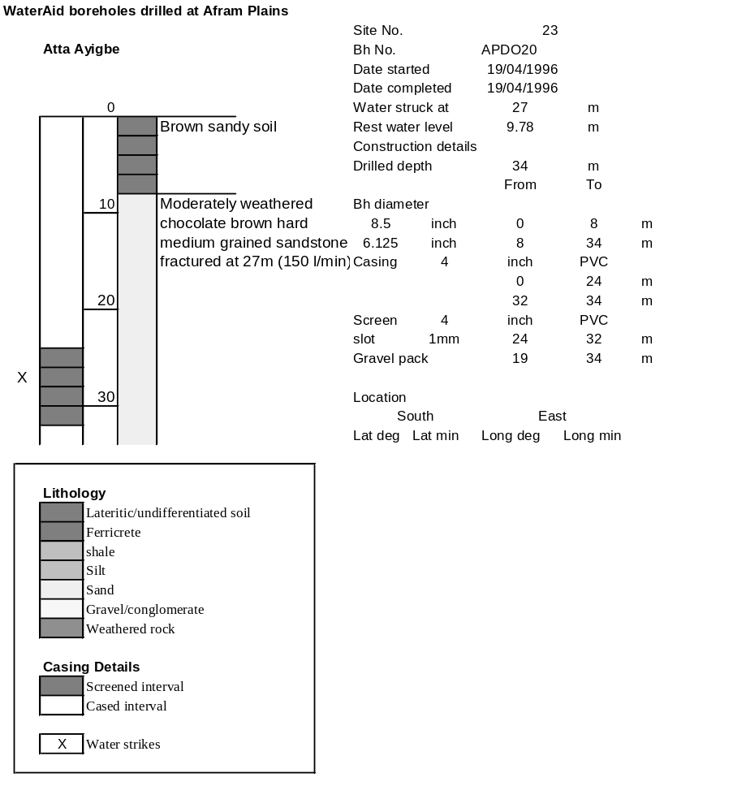

Ghana | Test pumping
Borehole No. |  | APDO20
Hole No |  | 23
Village |  | Atta Ayigbe
Date |  | 21/04/1996
Point above GL |  | 0.5 | m
Pump depth |  | 33 | m
SWL |  | 10.28 | m
Start Time |  | 08:40
Drawdown test |  |  |  |  | Recovery test
time | pwl (m) | Q l/min | s (m) | sc | Time | wl (m) | s' (m) | t/t'
0.00 | 10.28 | 120.00 | 0.00 |  | 0.00 | 25.66 | 15.38
1.00 | 13.20 | 120.00 | 2.92 | 41.10 | 1.00 | 23.30 | 13.02 | 181.00
2.00 | 14.00 | 120.00 | 3.72 | 32.26 | 2.00 | 22.57 | 12.29 | 91.00
3.00 | 14.55 | 120.00 | 4.27 | 28.10 | 3.00 | 22.05 | 11.77 | 61.00
4.00 | 15.02 | 120.00 | 4.74 | 25.32 | 4.00 | 21.68 | 11.40 | 46.00
5.00 | 15.42 | 120.00 | 5.14 | 23.35 | 5.00 | 21.33 | 11.05 | 37.00
6.00 | 15.77 | 120.00 | 5.49 | 21.86 | 6.00 | 21.05 | 10.77 | 31.00
7.00 | 16.05 | 120.00 | 5.77 | 20.80 | 7.00 | 20.85 | 10.57 | 26.71
8.00 | 16.33 | 120.00 | 6.05 | 19.83 | 8.00 | 20.57 | 10.29 | 23.50
9.00 | 16.59 | 120.00 | 6.31 | 19.02 | 9.00 | 20.36 | 10.08 | 21.00
10.00 | 16.88 | 120.00 | 6.60 | 18.18 | 10.00 | 20.16 | 9.88 | 19.00
11.00 | 17.07 | 120.00 | 6.79 | 17.67 | 12.00 | 19.80 | 9.52 | 16.00
12.00 | 17.29 | 120.00 | 7.01 | 17.12 | 14.00 | 19.47 | 9.19 | 13.86
13.00 | 17.49 | 120.00 | 7.21 | 16.64 | 16.00 | 19.20 | 8.92 | 12.25
14.00 | 17.67 | 120.00 | 7.39 | 16.24 | 18.00 | 18.96 | 8.68 | 11.00
15.00 | 17.87 | 120.00 | 7.59 | 15.81 | 20.00 | 18.70 | 8.42 | 10.00
16.00 | 18.05 | 120.00 | 7.77 | 15.44 | 22.00 | 18.50 | 8.22 | 9.18
17.00 | 18.20 | 120.00 | 7.92 | 15.15 | 24.00 | 18.30 | 8.02 | 8.50
18.00 | 18.35 | 120.00 | 8.07 | 14.87 | 26.00 | 18.11 | 7.83 | 7.92
19.00 | 18.50 | 120.00 | 8.22 | 14.60 | 28.00 | 17.94 | 7.66 | 7.43
20.00 | 18.68 | 120.00 | 8.40 | 14.29 | 30.00 | 17.78 | 7.50 | 7.00
22.00 | 18.97 | 120.00 | 8.69 | 13.81 | 35.00 | 17.42 | 7.14 | 6.14
24.00 | 19.24 | 120.00 | 8.96 | 13.39 | 40.00 | 17.10 | 6.82 | 5.50
26.00 | 19.52 | 120.00 | 9.24 | 12.99 | 45.00 | 16.81 | 6.53 | 5.00
28.00 | 19.76 | 120.00 | 9.48 | 12.66 | 50.00 | 16.55 | 6.27 | 4.60
30.00 | 20.00 | 120.00 | 9.72 | 12.35 | 60.00 | 16.10 | 5.82 | 4.00
35.00 | 20.29 | 120.00 | 10.01 | 11.99 | 70.00 | 15.71 | 5.43 | 3.57
40.00 | 20.61 | 120.00 | 10.33 | 11.62 | 80.00 | 15.38 | 5.10 | 3.25
45.00 | 20.84 | 120.00 | 10.56 | 11.36 | 90.00 | 15.07 | 4.79 | 3.00
50.00 | 21.10 | 120.00 | 10.82 | 11.09 | 100.00 | 14.79 | 4.51 | 2.80
55.00 | 21.59 | 120.00 | 11.31 | 10.61 | 110.00 | 14.53 | 4.25 | 2.64
60.00 | 21.99 | 120.00 | 11.71 | 10.25 | 120.00 | 14.32 | 4.04 | 2.50
70.00 | 22.68 | 120.00 | 12.40 | 9.68
80.00 | 23.25 | 120.00 | 12.97 | 9.25
90.00 | 23.74 | 120.00 | 13.46 | 8.92
100.00 | 24.17 | 120.00 | 13.89 | 8.64
110.00 | 24.54 | 120.00 | 14.26 | 8.42
120.00 | 24.86 | 120.00 | 14.58 | 8.23
130.00 | 25.18 | 120.00 | 14.90 | 8.05
140.00 | 25.52 | 120.00 | 15.24 | 7.87
160.00 | 25.47 | 120.00 | 15.19 | 7.90
180.00 | 25.66 | 120.00 | 15.38 | 7.80

